Unit - 2

PRODUCTION AND COST ANALYSIS

Meaning of Production:

Production refers to the transformation of inputs into outputs (i.e., goods and services). Inputs are the resources used in production of goods and services and are generally classified into four broad categories. These are:

- Land or Natural Resources.
- Labour
- Capital
- Organization

Q1). Define Production Function. Discuss in Detail Different Types of Production Functions.

Ans:

Definition:

Production Function is defined as “mathematical representation of the functional relationship between physical inputs (factors of production) and physical outputs (the quantity
of goods produced)”.

To get a certain amount of output what combination of inputs are required will be given out by the production function. Mathematically production function can be written as:

Q = f (a, b, c, d, ……………, n)

Where

- represents quantity of output f represents depends on

a, b, c, d, & n represent various production factors such as land, labour, capital and organisation. Here output becomes dependent variable and inputs becomes independent variables

Managerial use of Production Function: The production function is very much helpful to managers. The following are the managerial uses of production.

- Helpful in determining least cost combination.

- Helpful in taking cost control decisions.

- It helps to determine optimum level of output.

- Useful in drafting plans.

Types of Production Function: The production functions are classified as:

- Iso-Quants or Production Function with Two Variable Inputs.

- Law of Returns.

- Law of Returns to Scale.

- Statistical Production Function.

Note: The above production functions explained in detail in the following questions.

Q2). Define Iso-Quants? What are the properties of Iso-Quants?
Ans:

The term ‘Iso’ means equal and ‘Quant’ means quantity. Iso-quant means equal quantity.

Iso-quants are a geometric representation of the production function.

Iso-quant may be defined as “a curve which shows the different combinations of the two inputs producing the same level of output”.

Iso-quants are called as Iso-product curves, equal product curves or production indifference curves. The concept of iso-qunat is explained in the following table.

Combination | Capital | Labour | Total output
 | (in units) | (in units) | (in units)
A | 1 | 15 | 1000
B | 2 | 10 | 1000
C | 3 | 6 | 1000
D | 4 | 3 | 1000

In this above table, it shows by increase one input and decreasing another inputs in any of two inputs give you same output. For example 1unit capital and 15units of labour, 2units capital and 10units of labour gives you same output of 1000units.

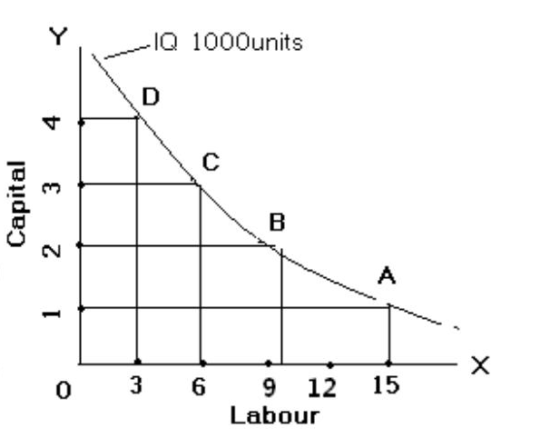

The Iso-quant curve is convex to origin. The above diagram shows the different combination of output factor (i.e., capital and labour) to produce an amount of 1000 units. The combination of A shows 1unit of capital and 15units of labour to produce 1000units. Similarly, B,C and D employs 2C + 10L, 3C + 6L, and 4c + 3L respectively to produce the same amount of output i.e., 1000 units.

Properties of Iso-Quants: Iso-quants have the following features:
- Iso-quants have a negative slope: Iso-quants always slope downwards from left to right. It implies that if one of the factor inputs is decreased, the other has to be increased so that the total output remains the same.

- Iso-Quants are convex to origin: Iso-quants must be convex to origin because of the Diminishing Marginal Rate of Technical Substitution (DMRTS). If we observe the above table, when the firm is employing the second unit of capital, it is withdrawing 5 units of labour, for the 3 units of capital, it is withdrawing 4 units of labour and so on. This is due to the fact as more units of one factor are employed the marginal productivity of the factor decreases and vice-versa. This is called DMRTS. Due to the DMRTS Iso-quants take a convex shape.

- Non-Intersecting: Iso-quants representing different levels of output never intersect or touch each other.

Q3). Define Iso-Cost and Explain.

Ans:

An Iso-cost curve is a curve or line representing equal cost. It shows all combinations of inputs having equal total cost.

To drawn an Iso-cost line, we require the information about unit prices of the two

factors and total outlay.

Example: | Total outlay is Rs.100.
 | Labour cost is Rs.10. per unit.
 | Capital cost is Rs.30 per unit.
 |  | Combination | Capital@30/- | Labour@10/- | Total outlay
 |  | A | 3 | 1 | 3*30+1*10=100
 |  | B | 2 | 4 | 2*30+4*10=100
 |  | C | 1 | 7 | 1*30+7*10=100

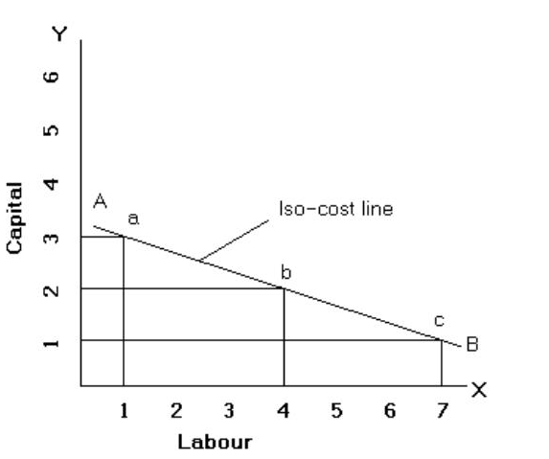
In the above table 3units of capital and 1unit labour total outlay is Rs.100. and 2units of capital and 4units of labour total outlay and 1unit of capital and 7units of labour total outlay is also Rs.100.

The iso-cost line AB is derived by joining the loci of points a, b and a, c represents alternative factor combination.

LAW OF VARIABLE PROPORTIONS

Q4). Define and explain diminishing returns to variable factor and why does it happen? Use suitable diagram in support of your answer. (Or)

Explain the law of variable proportions. What are its economic implications? Why the law of variable proportions operates?

Ans:

The affect of output of variations in factor proportions is called “The Law of Variable Proportions”. This law examines the production function with one factor input variable, while other factor inputs remain unchanged.

Definition:

The law of variable proportion is defined as “The quantity of one input is increased, keeping the quantity of other inputs fixed; the output increased in the beginning and afterwards decreases”.

Tabular Representation:

Suppose a former has one acre of land to cultivate. The amount of land and capital are supposed to fixed factors. The former can vary the number of labour to be employed on its cultivation. The changes in the number of labours will change the output also.-

 | Total Product | Average Product | Marginal Product
No. of Labour | (TP) | (AP) |  | (MP)
1 | 5 | 5 | 5
2 | 12 | 6 | 7 | Stage- I
3 | 21 | 7 | 9
4 | 28 | 7 | 7
5 | 30 | 6 | 2 | Stage- II
6 | 30 | 5 | 0
7 | 28 | 4 | -2
8 | 24 | 3 | -4 | Stage-III

In the above table we assume that the land is fixed and successive units of labour are employed. It can be seen that there are three different stages of law of diminishing returns.

- The Law of Diminishing Total Returns: In the total output the returns begin to diminish from the 7th labour. Every successive labour employed does make some addition to the total output but 6th adds nothing and 7th unit of labour causes diminishing output.

- Law of Diminishing Average Returns: The average product reaches maximum at the 3rd labour. The marginal product and average product are equal at the point at where 4th labour is employed. It starts diminishing from 5th labour.
- Law of Diminishing Marginal Returns: The marginal Product is increasing up to 3rd labour employed. The additional return is falling from the 4th labour onwards till it drops down to zero, at the 6th labour and after negative.

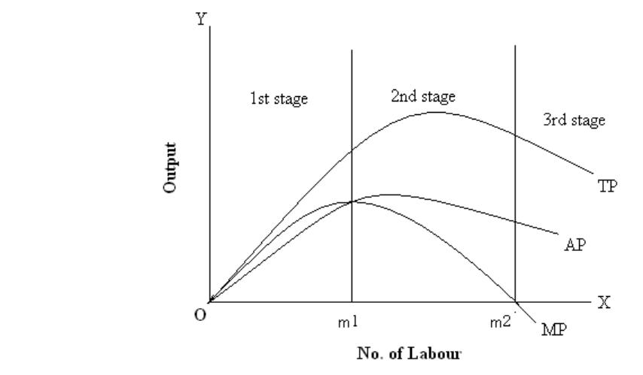

In the above diagram output is shown on Y-axis and No. of labour shown on X-axis. The curves TP, AP and MP represent the Total Product, Average Product, and Marginal Product respectively. This diagram shows three stages of returns.

1st Stage – Increasing Returns: In the 1st stage the average product of labour increases, which reflects the increase in efficiency of labour. Hence, this stage is known as increasing returns.

2nd Stage – Constant Returns: In the second stage it shows decreasing average and marginal product of labour. Since the total output goes on increasing, the marginal product is positive. This stage shows the decreasing efficiency of labour but the efficiency of land continues to increase.

3rd Stage – Diminishing Returns: In this stage, the average product decreases still further. The MP becomes negative and the TP starts decreasing. Hence, in this stage both labour and land efficiency has been used inefficient.

Assumptions or conditions of Law of Variable Proportions: The Law of Diminishing Returns is based on the following assumptions:

- Constant Technology

- Short-run

- Homogeneous factors

- Factor Proportions

ECONOMIES OF SCALE

Q5). Discuss various types of economies available to a firm.

Economies of Scale:
As a result of the large scale production the production cost is low, and it is known as economies of scale.

Definition:

“As long as the output is increased in the long-run, the cost of production will be at minimum level; this is known as economies of scale”.

Alfred Marshall divided the economies of scale into two groups. They are:

Types of Economies of Scale

Internal Economies

- Labour economies
- Technical economies
- Managerial economies
- Marketing economies
- Financial economies

- Risk bearing economies

External Economies

- Economies of Localisation
- Economies of Information

- Growth of Subsidiary Industry

- Economies of By-Products

- Internal Economies:

Internal economies are those benefits or advantages enjoyed by an individual firm if it increases its size and the output.

- Labour economies: A large firm can attract specialist or efficient labour and due to increasing specializations the efficiency and productivity will be increased, leading to decrease in the labour cost per unit of output.

- Technical Economies: A large firm can adopt and implement the new and latest technology which helps in reducing the cost of manufacturing process, whereas the small firm may not have the capability to implement latest technologies.

- Managerial Economies: The managerial cost per unit will decrease due to mass scale production. Like the salary of general manager which remains the same whether the output is high or low. Moreover, a large firm can recruit the skilled professionals by paying them much of capacity to pay high salaries. Thus, mass scale of production will decrease the managerial cost per unit.

- Marketing Economies: A large firm can purchase their requirements on a bulk scale therefore, they get a discount. Similarly the advertisement cost will be reduced because a large firm produces a variety of different types of products. Moreover, a large firm can employ scale professional for marketing their products effectively.

- Financial Economies: A large firm can raise their financial requirements easily from different sources than a small one. A large firm can raise their capital easily from the capital market because the investor has more confidence on the large firm than in small firm.

- Risk Bearing Economies: The large firm can minimize the business risk because it produces a variety of products. The loss in one product line can be balanced by the profit in other product line.

- External Economies:

External economies are those benefits which are enjoyed by all the firms in an industry irrespective of their increased size and output.

- Economies of Localization: When all the firms are situated at one place, all the firms will be enjoying the benefits of skilled labour, infrastructure facilities and cheap transport thereby reducing the manufacturing cost.

- Economies of Information: All the firms in an industry can have a common research and development centre through which the research work can be undertaken jointly. They can also have the information related to market and technology.

- Growth of Subsidiary Industry: The production function process can be divided into different components. Each component can be manufactured by specialized firms at a low cost.

- Economies of By-Products: The waste materials released by a particular firm can be used as an input by the other firm to manufacture a by-product.

COBB-DOUGLAS PRODUCTION FUNCTION

Q6). Explain Cobb – Douglas Production Function.

The American economists C.W.Cobb and P.H.Douglas have undertaken an extensive survey in some manufacturing industries in America from 1899 to 1922 to find out the relationship between the physical input and physical output and formed an empirical production function, popularly known as ‘Cobb-Douglas Production Function’. The general form of Cobb – Douglas production may be described as:

- 1-a
P=b ( L C )

Where,

P = Total Output

b=Positive constant.

L = Quantity of Labour

C = Quantity of Capital

The exponents ‘a’ and ‘1-a’ are the elasticity of production.

According to this they were observed that 1/4th proportion of capital and 3/4th proportion of labour contributed towards the improvement of productivity. Therefore, productivity function can be written like this:

P = b (L ¾ C ¼) | OR | P = b (L0.75 C0.25)

Thus for a given change in labour and capital factor the productivity will change. 0.75 labour factor together with 0.25 capital factor results in productivity 1 (0.25 + 0.75). Thus for every one percent change in labour as well as capital factors result in one percent change in productivity. According to Cobb-Douglas if the output has to increase by 1% the input has to increase in the same proportion.

COST CONCEPTS

Q7) Define Cost. How are costs classified?

Ans:

Cost is expenses incurred in producing a commodity. In producing a commodity, a firm has to employee an aggregate of various factors of production such as land, labour, capital and entrepreneurship. The producer should pay compensation to these different factors of production. This compensation is called as cost.

➢ Types of Cost:

1. Actual Costs Vs Opportunity Costs:

Cost of inputs to produce a product. Example, wages paid, expenses of raw material, machinery etc., these are called as actual cost or outlay cost.

Opportunity cost refers to the “cost of next best alternative foregone”. Opportunity cost is said to exit when the resources are scarce and there are alternative uses for these resources. If there is no alternative, there is no opportunity cost.

Eg: A company has deposited Rs.1 lakh in bank at 10% p.a. interest. If the company decides to withdraw deposit in bank to invest in a new project, it will have to forego bank interest of Rs.10,000 p.a. which is the opportunity cost.

2. Incremental Costs Vs Sunk Costs:

Incremental costs are the added costs of the change in the level of production or nature of activity. Example adding new machinery, adding new product, changing distribution channel and so on.

Sunk costs are cannot be altered or changed by changing in the level or nature of business activity; they will remain same whatever the level or activity. For example, factory building constructed, cost has already been incurred. It cannot be altered or changed when operations are increased or decreased.

3. Past Costs Vs Future Costs:

Past costs are actual costs incurred in the past. These costs are mentioned in financial accounts. The management cannot rectify the past cost.

Future cost are those costs are which are to be incurred in the near future. If the management considered the future costs are very high it can reduce them or postponed the use of them.
4. Historical Costs Vs Replacement Costs:

Historical costs are those costs that have been originally spent to acquire the assets. In contradiction, replacement costs are those costs that are to be paid currently if the assets were to be replaced.

For example, if the price of equipment in 2005 was Rs.10,000 and which is replaced by the same equipment now cost Rs.13,000 (i.e., 2014), then we can say the historical cost if equipment is Rs.10,000 and the replacement cost will be Rs.13,000.

5. Fixed Costs Vs Variable Costs:

Fixed costs are those costs that do not vary with the size of its output. These costs associated with the fixed factors like rent, salaries, buildings, machinery and so on.

Variable costs are those costs which change with the changes in the volume of output.

These costs associated with the variable factors like raw-material, power and so on.

6. Short run Costs Vs Long run Costs:

This cost distinction is based on the time element. Short run is a period during which the physical capacity of the firm remains fixed. Any increase in output during this period is possible only by using the existing physical capacity more intensively.

Long run is a period during which it is possible to change the firm’s physical capacity. All the inputs are variable in the long run cost.

7. Direct Costs Vs Indirect Costs:

When the cost can be easily identified with a unit of operation it is called as direct cost. Ex: if the cost of raw material is Rs.20000 and if 5,000 units are produced, it may be said that the cost of raw material per unit is Rs.4.

When the cost cannot be easily identified with a unit of operation it is called as indirect cost. Ex: salary of GM cannot be traced unit wise.

8. Explicit Costs Vs Implicit Costs:

Explicit costs are those expenses that involve cash payments. These costs include payment of wages & salaries, payment for raw materials etc. These are the actual costs that appear in the accounting books.

Implicit costs are the costs of the input factors that are owned by the employer himself. It does not involve cash payment and hence does not appear in the accounting books. Ex: cost of depreciation, interest on capital, rent unclaimed on own buildings, salary undrawn for entrepreneur’s services etc.

9. Out of Pocket Costs Vs Imputed Costs:
Out of pocket costs also known as explicit costs are those costs that involve cash payments to outsiders. Ex: payment of electricity bill, the purchase prices of a new equipment etc.

Imputed costs also called implicit costs do not involve cash payment. Even though such costs do not involve any cash payment but are taken into consideration while making managerial decisions. Ex: depreciation, interest on capital, rent unclaimed on own buildings, salary of owner etc.

- Marginal Cost: The additional cost incurred to produce an additional unit of product is called marginal cost.

- Semi-fixed or Semi-variable Costs:

Those costs refer to such costs that are fixed to some extent beyond which they are variable. Ex: telephone charges or electricity charges.

COST-VOLUME-PROFIT ANALYSIS

Q8). Explain in brief CVP analysis.

Definition:

“CVP analysis is the study of the effects on future profits of changes in fixed cost, variable cost, sales price, quantity and mix.”

------- CIMA London

The intention of every business activity is to earn the profit. Profits of business firms are the result of many factors such as i).Selling Prices, ii).Volume of Sales, iii). Unit Variable Cost, iv).Total Fixed Cost, etc. To do an effective job, Cost-Volume-Profit (CVP) analysis is useful to management for studying the relationship between volume, cost, prices and profits. Within these factors, there is a cause and effect relationship. For example: profit depends upon sales, selling price to a large extent depends upon cost and cost depends to a large extent upon volume of production, as it is only the variable cost that varies directly with production.

A CVP analysis is extremely useful to the management in budgeting and profit planning.

It explains the impact of the following on the net profit:

- Changes in Selling Price

- Changes in Volume of Sales

- Changes in Variable Cost

- Changes in Fixed Cost

CVP analysis uses the techniques of (i) Profit-Volume Analysis and (ii) Break-even

Analysis.

BREAK - EVEN ANALYSIS
Q9). What is meant by break-even analysis? Explain the uses and limitations of BEP. (Or) Describe the Break-even point with the help of diagram and its uses in business decision-making.

Ans:

Break-even analysis refers to analysis of break-even point (BEP). It is also called the Cost-Volume-Profit analysis.

The break-even is defined as “a point at which firm has no profit and no loss. Cost is equal to revenue.” Before a firm plans for profit maximization it has to determine the Break-Even Quantity or value of output it should produce.

Significance of Break-even Analysis: Break-even Analysis has a lot of practical importance to decision makers. They are:

- To understand the Break-even Quantity.

- To known the impact of changes in fixed costs on the Break-even Quantity and profits.

- To known the impact of changes in variable costs on the Break-even Quantity and profits.

- To get target profits.

- To understand the margin of safety.

- To initiate changes in prices.

- Add or Drop decision.

- Make or Buy decision.

Limitations of Break-even Analysis:

- It assumes price to remain constant.

- Seperability of costs into Fixed and Variable.

- It has limited use in case of Multi-product firms.

- There is no change in government policies.

- Availability of Cost-Volume-Profit data.

CALCULATION OF BREAK-EVEN POINT: Break-even point can be calculated in two methods.

They are:

  - Graphical Method

  - Mathematical Method.

- Graphical Representation of BEP:

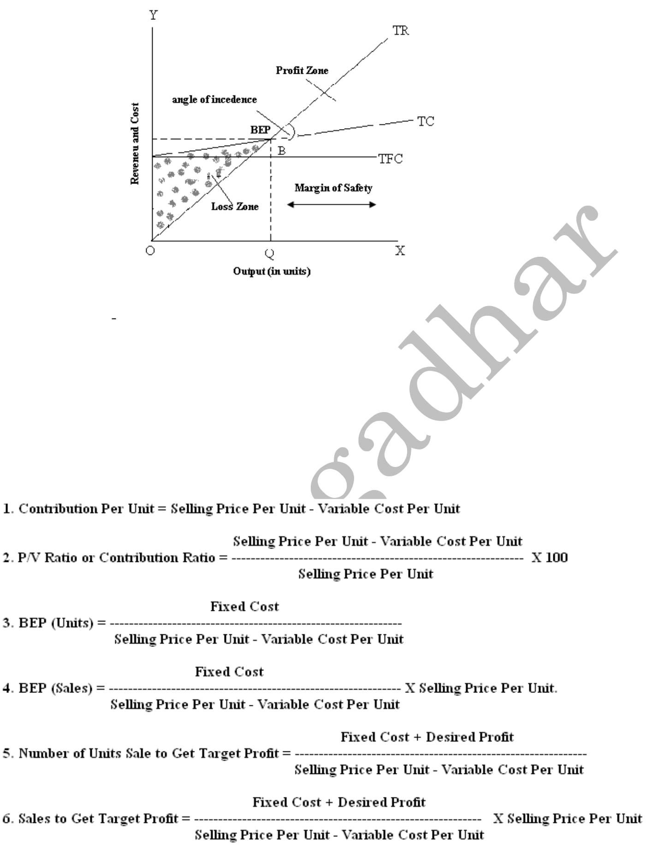

In the above graph, at output level of ‘OQ’ the total revenue is equal to total cost i.e., BQ, where the firm is neither getting profit not loss. Hence OQ is the break-even quantity of output. At output level less than OQ the firm is suffering losses and beyond that it is reaping profits.

- Mathematical Method: In this method by applying the following formulas BEP can be calculated.

BEP formulas

When Per Unit data is Given
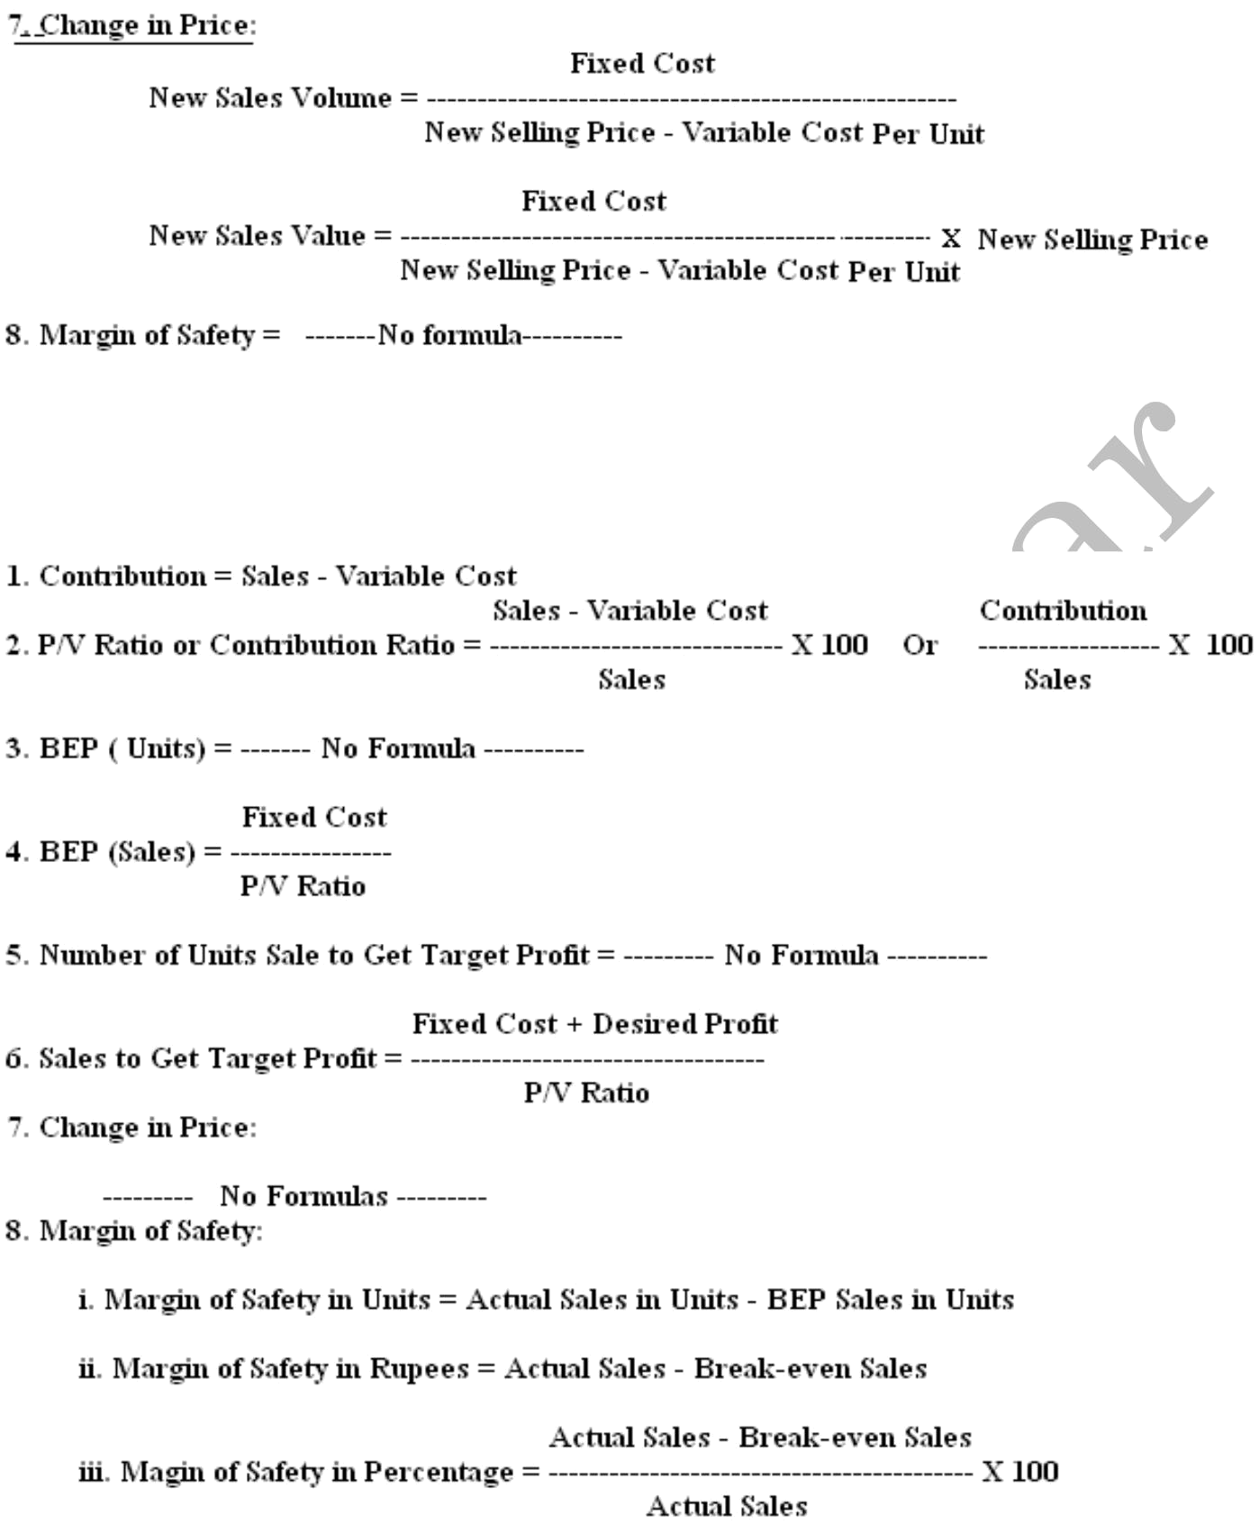

When Overall Data is Given

When two years data is given P/v ratio formula is:
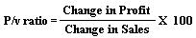

QUIZ

1. The cost of best alternative forgone is_______________ ( )

(a) Outlay cost (b) Past cost
(c) Opportunity cost (d) Future cost
2. If we add up total fixed cost (TFC) and total variable cost (TVC), we get__ ( )
(a) Average cost (b) Marginal cost
(c) Total cost (d) Future cost
3. ______costs are theoretical costs, which are not recognized by the accounting system. ( )
(a) Past (b) Explicit
(c) Implicit (d) Historical
4. _____cost is the additional cost to produce an additional unit of output. ( )
(a) Incremental (b) Sunk
(c) Marginal (d) Total
5. _______ costs are the costs, which are varies with the level of output. ( )
(a) Fixed (b) Past
(c) Variable (d) Historical
6. _______ costs are those business costs, which do not involve any cash payment. ( )
(a) Past (b) Historical
(c) Implicit (d) Explicit
7. The opposite of Past cost is ________________________. ( )
(a) Historical (b) Fixed cost
(c) Future cost (d) Variable cost
8. _____ is a period during which the existing physical capacity of the firm can be changed.( )
(a) Market period (b) Short period
(c) Long period (d) Medium period
9. What is the formula for Profit-Volume Ratio? ( )
Sales Variable cost
(a) --------------- X 100 (b) ----------------- X 100
Contribution Sales
Contribution Fixed cost
(c) --------------- X 100 (b) ----------------- X 100
Sales Sales
10. _______ is a point of sales at which there is neither profit nor loss. ( )
(a) Maximum sales (b) Minimum sales
(c) Break-Even sales (d) Average sales
11. What is the formula for Margin of Safety? ( )
(a) Break Even sales – Actual sales (b) Maximum sales – Actual sales
(c) Actual sales – Break Even sales (d) Actual sales – Minimum sales
12. What is the formula for Break-Even Point in Units? ( )
(a) __Contribution_____ (b) __Variable cost____
Selling Price per unit Contribution per unit
(c) _ _Fixed cost _____ (d) __Variable cost____
Contribution per unit Selling Price per unit
13. | What is the Other Name of Profit Volume Ratio? |  | ( | )
 | (a) Cost-Volume-Profit Ratio | (b) Margin of safety Ratio
 | (c) Marginal Ratio | (d) None
14. | What is the break-even sales amount, when selling price per unit is 10/- , Variable cost per
unit is 6/- and fixed cost is 40,000/-. |  |  | ( | )
 | (a) Rs. 4, 00,000/- | (b) Rs. 3, 00,000/-
 | (c) Rs. 1, 00,000/- | (d) Rs. 2, 00,000/-
15. | ‘Contribution” is the excess amount of Actual Sales over ______. |  | ( | )
 | (a) Fixed cost | (b) Sales
 | (c) Variable cost | (d) Total cost

UNIT-II Imp Questions
Essay Questions:

- Define production Function. Discuss in detail the different types of production functions. (Or) Discuss in detail the different methods of production functions.

(R07 Nov-2009, R10 Nov-2011, R07 May-2013)

- What are iso-quants? Explain the chief characteristics of iso-quants.
(R10 Nov-2011, R07 May-2013, R07 Dec-2013)

- Define and explain diminishing returns to variable factor and why does it happen? Use suitable diagram in support of your answer. (Or) Explain the law of variable proportions. What are its economic implications? Why the law of variable proportions operates?

(R07 Nov-2009, R07 May-2011, R07 Dec-2013)

- What is meant by internal and external economies of scale? Discuss various types of economies available to a firm.

(R07 Nov-2009, R07 May-2013)

- Define ‘Cost’. How are costs classified? Explain any five important cost concepts useful for managerial decisions.

(R07 May-2009, R07 Nov-2011, R07 May-2013)

- What is meant by break-even analysis? Explain the uses and limitations of BEP. (Or) Describe the Break-even point with the help of diagram and its uses in business decision-making.

(R07 May-2009, R07 Nov-2010, R07 Nov-2011, R07 May-2013, R07 Dec-2013)

- BEP Problems

(R07 May-2011, R07 May-2009, Nov-2010, R07 Nov-2011, R07 May-2011)

Short Answers:

- Production function
- Iso-quants
- Iso-costs
- Cobb-Douglas production function
- Opportunity cost
- Fixed costs Vs Variable costs
- Explicit costs Vs Implicit costs

- Out of Pocket Costs Vs Imputed Costs
- CVP analysis
- BEP

